

**-Ashulia, Saver, Dhaka**

**A Project Report**

**On**

**MEAL MANAGEMENT SYSTEM**

For

Spring 2019

4ht semester

SUBMITTED BY:

Akash Ahmed

ID:181-15-1714

Md.Shahin Shah Murad

ID:181-15-1838

Mededi hassan Shovo

ID:181-15-1821

Under the Guidance of:

Md.Reduanul Haque

Department of CSE

**Declaration**

We declare this project entitled “Meal management system” done at Daffodil International University is a record of project work submitted us for management of a meal of any ordering hotel room facility.

The Project is genuine and not a reproduction of any project previously done or submitted.

-Akash Ahmed

- Md.Shahin Shah Murad

- Mededi hassan Shovo

Acknowledgement

I extend my sincere thanks to Daffodil International University which provided us

with the opportunity to fulfill wish and achieve our goal.

I would like to express deep debt to Md.Reduanul Haque

(Computer Science), project guide for his vital

suggestions, meticulous guidance and constant motivation which

went a long way in the successful completion of this project.

I cannot move on without thank beloved Md.Reduanul haque for creating the required academic

environment which made my task appreciable.

- Md.Shahin Shah Murad

- Akash Ahmed

- Mehedi Hasan Shuvo

CERTIFICATE

This is to certify that the Dissertation entitled, **Meal management system** is a benefited work

done by Akash Ahmed, Md.Shahin Shah Murad, Mededi Hassan Shovo of DIU during the academic session 2019 is partial fulfillment of CSE.

Examination 2019 and has been carried out under me

direct supervision and guidance. This report or a similar

report on the topic has not been submitted for any other

examination and does not form a part of any other course

undergone by the candidate.

_________________

Signature of Teacher

(Md.Reduanul Haque )

**Daffodil International University**

**INTRODUCTION**

The project titled “Meal Management System” is a billing system for a fast meal system. This project is designed

And coded in NetBeans 8.0.3 & database. Management is handled by MySQL 5.0.8. This project mainly focused on basic

Things for 1st page log in, options and information. Our project is easy to use for both Manager and Safe.

**This software has four main modules:**

* Insertion to Database Module.
* Deletion to Database Module.
* Food Items.
* Result

**SYSTEM ANALYSIS**

**EXISTING SYSTEM:**

System Analysis is a detailed study of the various operations performed by a system and their relationships within and outside of the system. Here the key question is-

what all problems exist in the present system? What must be done to solve the problem? Analysis begins when a user or manager begins a study of the program

using existing system.

During analysis, data collected on the various files, decision points by the present system. Training, experience and common sense are required for collection of relevant information needed to develop the system. The success of the system depends largely on how clearly the problem is defined, thoroughly investigated and properly carried out through the choice of solution.

A good analysis model should provide not only the mechanisms of problem understanding but also the frame work of the solution. Thus, it should be studied thoroughly by collecting data about the system. Then the proposed system should be analyzed thoroughly in accordance with the needs.

**System analysis can be categorized into three parts:**

* System planning and initial investigation
* Information Gathering
* Applying analysis tools for structured analysis
* Cost/ Benefit analysis.

**PROPOSED SYSTEM**

Proposed system is an automated Meal Management System. Through our software user can add name, add room number, take food order, number of orders, update, and cancel order, edit information, in quick time. Our proposed

system has the following advantages.

* User friendly interface
* Fast access to database
* Less error
* More Storage Capacity
* Look and Feel Environment
* Quick transaction
* Cancelling order

All the manual difficulties in managing the Library have been rectified by implementing computerization.

**FEASIBILITY ANALYSIS**

Whatever we think need not be feasible. It is wise to think about the feasibility of any problem we undertake. Feasibility is the study of impact, which happens in the organization by the development of a system. The impact can be either positive or negative. When the positives nominate the negatives, then the system is considered feasible. Here the feasibility study can be performed in two ways such as technical feasibility and Economical Feasibility.

* **Technical Feasibility:**

We can strongly say that it is technically feasible, since there will not be much difficulty in getting required resources for the development and maintaining the system as well. All the resources needed for the development of the software as well as the maintenance of the same is available in the organization here we are utilizing the resources which are available already.

* **Economic Feasibility:**

Development of this application is highly economically feasible. The organization

needed not spend much m one for the development of the system already available. The only thing is to be done is making an environment for the development with an effective supervision. If we are doing so, we can attain the maximum usability of the corresponding resources. Even after the development, the organization will not be in a condition to invest more in the organization. Therefore, the system is economically

feasible.

**MINIMUM HARDWARE REQUIREMENTS**

* Processor: intel CORE i5
* RAM: 128 MB or more
* Hard Disk: 20GB
* Monitor: Any
* Key Board: 122 Keys

**MINIMUM SOFTWARE REQUIREMENTS**

* Operating System: Windows 98, Windows XP, Windows 7 or better
* Language: Java 7 Runtime Environment or better
* Front End: NetBeans 8.2.0
* Back End: MySQL server 5.1

**SOFTWARE INTERFACE**

* **Login From**

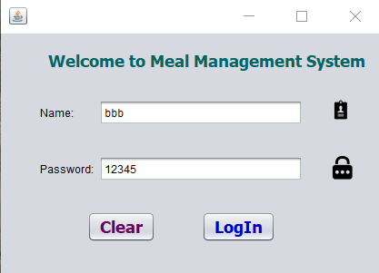

* **Options:**

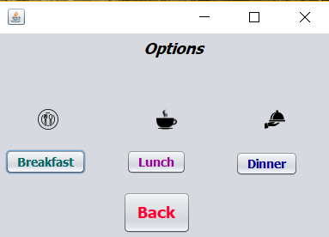

* **Breakfast Information Page:**

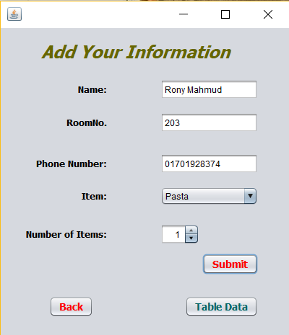

* **Data table (For Manager):**

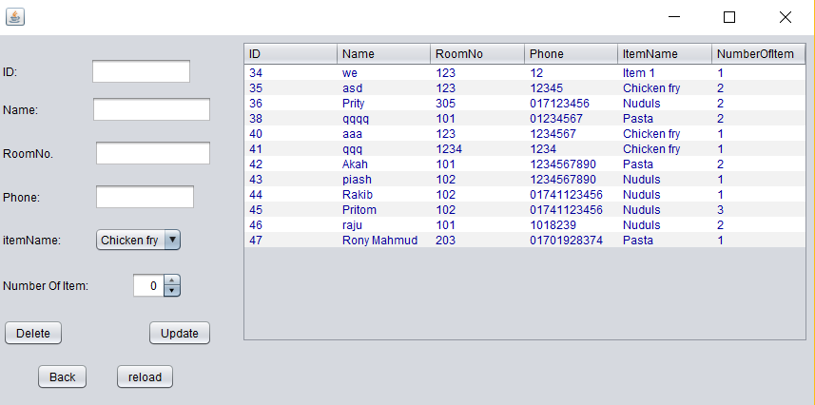

* **Data table (For shape)**

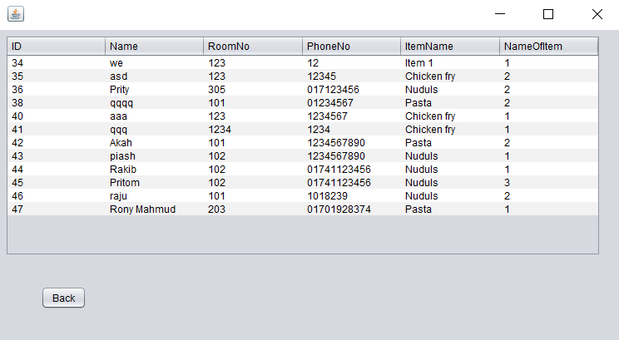

**SYSTEM DESIGN**

* **Input Design:**

Input design is the process of converting user-oriented input to a computer based format. Input design is a part of overall system design, which requires very careful attention. Often the collection of input data is the most expensive part of the system.

**The main objectives of the input design are:**

1. Produce cost effective method of input

2. Achieve highest possible level of accuracy

3. Ensure that the input is acceptable to and understood by the staff.

**Input Data:** The goal of designing input data is to make enter easy, logical and freeform errors as possible. The entering data entry operators need to know the allocated space for each field; field sequence and which must match with that in the source document. The format in which the data fields are entered should be given in the input form. Here data entry is online; it makes use of processor that accepts commands and data from the operator through a key board. The input required is analyzed by the processor. It is then accepted or rejected. Input stages include the

following processes:

* Data Recording
* Data Verification
* Data Control
* Data Correction

One of the aims of the system analyst must be to select data capture method and devices, which reduce the number of stages so as to reduce both the changes of errors and the cost. Input types, can be characterized as.

* External
* Internal
* Operational
* Computerized
* Interactive

Input files can exist in document form before being input to the computer. Input design is rather complex since it involves procedures for capturing data as well as inputting it to the computer.

* **Output Design:**

Outputs from computer systems are required primarily to communicate the results of processing to users. They are also used to provide a permanent copy of these result for latter consultation. Computer output is the most important and direct source of information to the users. Designing computer output should proceed in an organized well throughout the manner. The right output must be available for the people who find the system easy to use. The outputs have been defined during the logical design stage. If not, they should have defined at the beginning of the output designing terms of types of output connect, format, response etc.

Various types of outputs are:

• External outputs

• Internal outputs

• Operational outputs

• Interactive outputs

• Turn around outputs All screens are informative and interactive in such a way that the user can full fill his requirements through asking queries.

**TABLES USED**

* **Table Name: login form**

|  |  |  |
| --- | --- | --- |
| **NAME** | **TYPE** | **ATTRIBUTES** |
| Name | Varchar(55) | Unique |
| Password | Varchar(55) | Unique |

* **Table Name: Add information**

|  |  |  |
| --- | --- | --- |
| **Name:** | **TYPES** | **ATTRIBUTES** |
| Name | Varchar(55) |  |
| Room No | Varchar(55) |  |
| Phone Number | Varchar(55) |  |
| Item | Varchar(55) |  |
| Number of Items | Varchar(55) |  |

**CONCLUSION**

This was an effort to develop a simple meal Management System which may be useful in a meal to insert, Retype, display update and delete information. We hope you will like it.

Thank You